
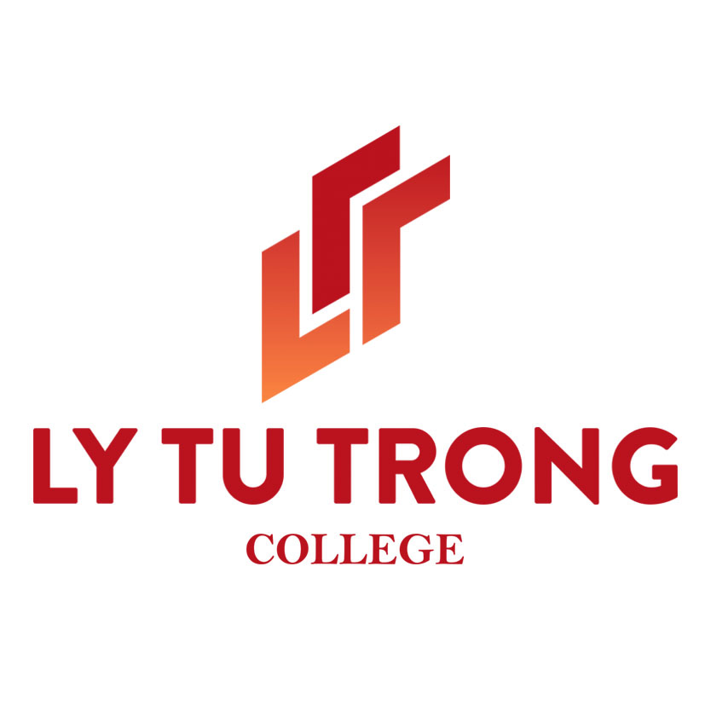

ACADEMIC AGREEMENT

between

Southern Taiwan University of Science and Technology

And
Ly Tu Trong College of Ho Chi Minh City, Viet Nam

Southern Taiwan University of Science and Technology (STUST), Taiwan and Ly Tu Trong College of Ho Chi Minh City, Viet Nam, recognizing the benefits to their respective universities from the establishment of institutional links, conclude this Agreement.
- The purpose of this Agreement is to develop academic and educational cooperation and promote mutual understanding between the two universities.
- Both universities agree to develop the following collaborative activities in academic areas of mutual interest, on the basis of equality and reciprocity:

- Exchange of faculty, researchers and other research and administrative staff;
- Exchange of students;
- Conduct of collaborative research projects;
- Conduct of lectures and symposia;
- Exchange of academic information and materials;
- Promote other academic cooperation as mutually agreed upon.

- The development and implementation of specific activities based on this Agreement will be separately negotiated and agreed upon between the faculties, schools or institutes which carry out the specific projects. Both universities agree to carry out these activities in accordance with the laws and regulations of the respective countries after full consultation and approval.

- It is understood that the implementation of any of the types of cooperation stated in clause 2 may be restricted depending upon the availability of resources and financial support at the universities concerned.
- Should any collaborative research activity under this Agreement result in any potential for intellectual property, both universities shall seek an equitable and fair understanding as to the ownership and other property interests that may arise. This understanding shall be based on the laws, rules and guidelines then implemented in each university.
- This Agreement may be amended or modified by a written agreement signed by the representatives of both universities.
- In the event of any unforeseen incident during collaborative activities in either country, both universities agree to negotiate a mutually acceptable solution. As far as practicable these solutions shall be incorporated in the specific agreements mentioned in clause 3.
- This Agreement is valid for a period of five (05) years from the date of signing by the representatives of both universities. This Agreement shall be renewed after being reviewed and renegotiated by both universities.
- This Agreement may, at any time during its period of validity, be terminated by one of the universities, upon prior notice to the other in writing no later than six (06) months before the termination date.
- Should any disagreement arise out of the application, interpretation or implementation of this Agreement, the universities shall endeavor to exercise best efforts to negotiate their differences. Alternative methods of dispute resolution shall be exhausted before resorting to court litigation.

Ly Tu Trong College of Ho Chi Minh City Southern Taiwan University
Viet Nam of Science and Technology

By: By:

_________________________ _________________________
Phạm Hữu Lộc Deng-Maw LU
Rector Interim President
Date: Date:

